43.53: a) Only the heavier one 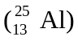can decay into the lighter one 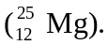
b) is a positron
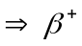 decay
or is an electron
 electron capture
c) Using the nuclear masses, we calculate the mass defect for 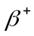 decay:
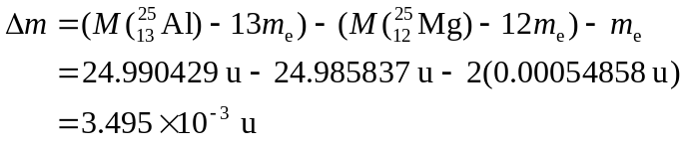
For electron capture:
